Updating Website

#1 - Log Into GoDaddy : <http://www.godaddy.com/>

Login : SGBoyscouts

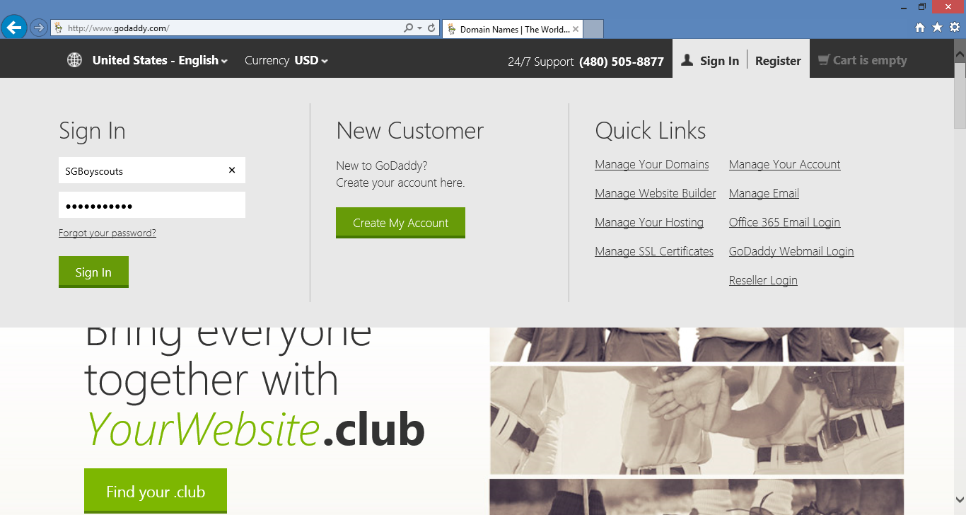

#2 – Expand WEB HOSTING, and click Launch

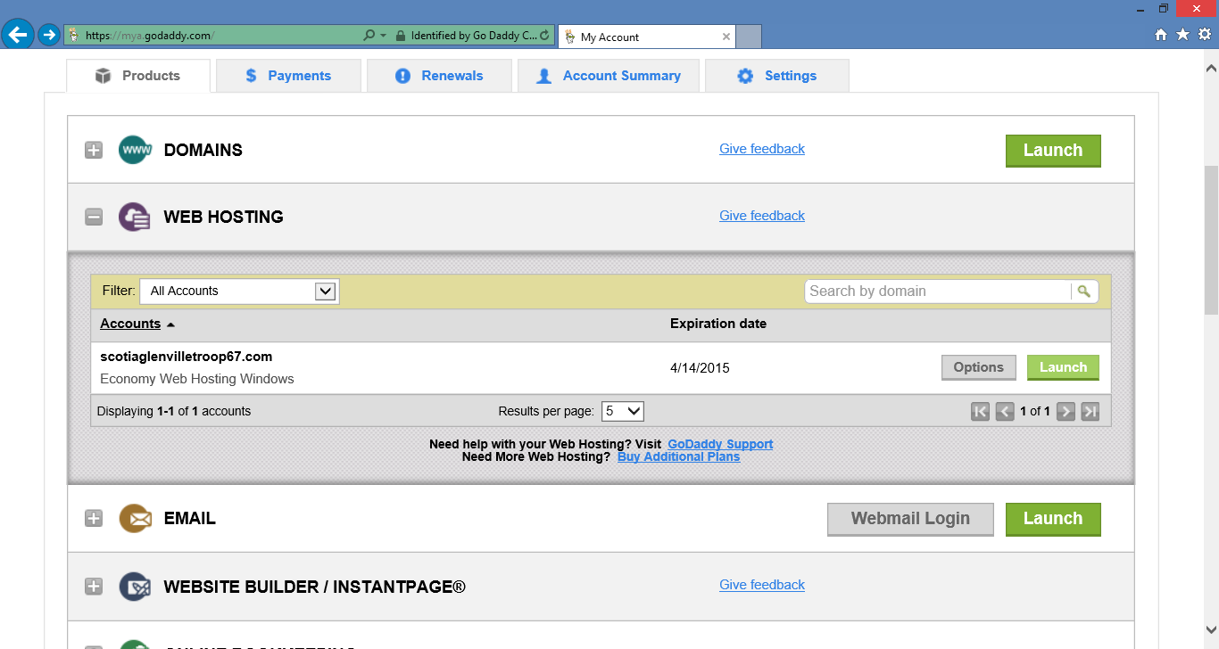

#3 – Click **Files & FTP** at top of page. Then choose **File Manager**

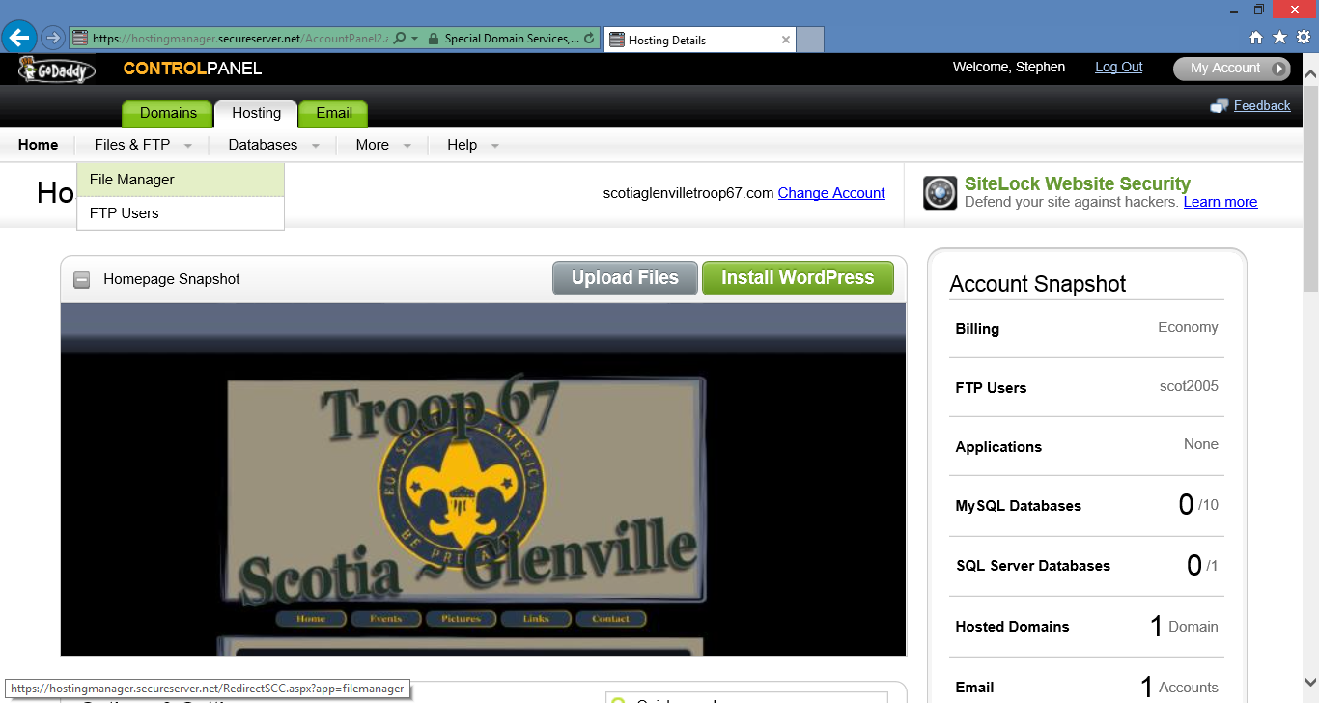

#4 – Click **Upload File** and then Click **Browse**. Navigate to the file on your machine.

Select your file and choose **Open**. Then Check **Overwrite files**.

Then Click **Upload**.

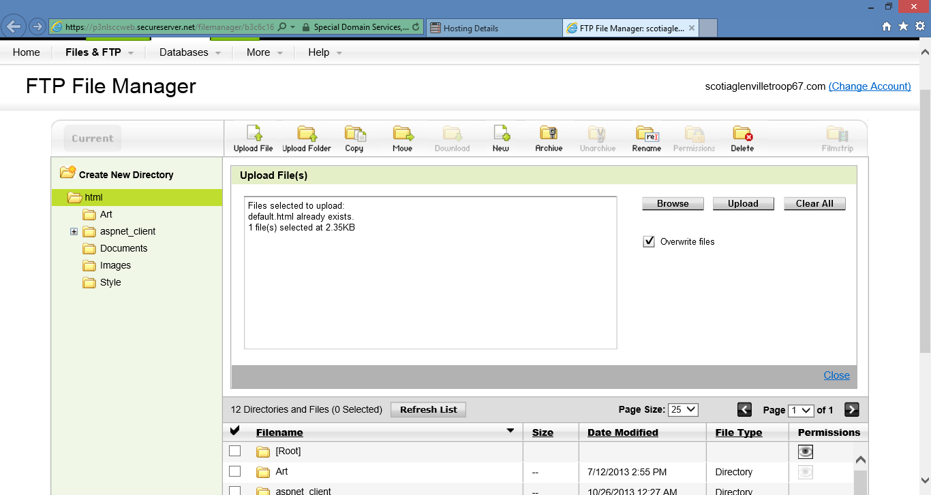

#5 Go to Boyscouts web site and make sure your change took effect.

<http://www.scotiaglenvilletroop67.com/events.html>

